**AMERICAN INTERNATIONAL UNIVERSITY- BANGLADESH**

**Project on**

**“Software Requirement Engineering”**

**Spring 18-19**

**Project Name**

**“Online Secondhand Book Buy and Sell System”**

**Under the supervision of**

Farzana Bente Alam

Faculty, Dept. of Science and information Technology

American International University – Bangladesh

**Members**

|  |
| --- |
| Ahsan Habib  ID: 17-34014-1  ahsanpolok156633@gmail.com |
| Tarik Bin Shams  ID: 17-33997-1  binshams.aiub@gmail.com |

**Date of Submission: 06.04.19**

**Table of Contents**

**Topic Page Number**

1. Introduction

1.1.1 Purpose 1

1.1.2 Our Solution to the Problem 1

1.2 Document Convention 1

1.3 Project scope 2

1.4 References 2

2. Overall Description

2.1 Productive perspective 2

2.2 User classes and characteristics 3

2.3 Operating Environment 4

2.4 Design and implementation constraints 4

3. System Features

3.1 Description of feature 5

           3.2 User requirements   8

           3.3 Functional requirements   9

           3.4 Cross reference   11

           3.5 Use Case 12

4. External Interface Requirements

4.1 User Interface 13

           4.2 Hardware Interface 18

           4.3 Software Interface 18

           4.3 Software Interface 18

5. Quality Attributes

5.1 Usability 19

5.2 Performance 19

6. Data Requirements

6.1.1 As is process diagram 20

           6.1.2 To be process Diagram 21

            6.2 Data Dictionary 22

**1. Introduction:**

People often dispose their old books. That way they waste their valuable money as well as importance of the books. Books play a significant role in our daily lives. The interest for books depends largely on its price. There can be a very important book that someone had longed to read but because of its high price, he/she could not afford it. It is a very common problem for most of the students. Many students have to struggle for buying new textbooks. On the other hand, there are many books that are stored in bookshelves that have not been read for years. Thus these books become useless and do not provide any value to anyone. In many scenarios, they often become harmful to the environment.

**1.1.1 Purpose:**

The purpose of this document is to give a detailed description of the requirements for the Online Second Hand Book Buy and Sell system. It will illustrate the complete declaration for the development of the system. It will also explain system constraints, interface and interaction with other external application. Defining and describing the functions and specifications of the system is the primary goal of this software requirements specification (SRS).

**1.1.2 Our Solution to the Problem:**

We propose an “Online Secondhand Book Buy and Sell System” for the above mentioned problem. In the current situation, this type of system has not been activated. So we think “Online Secondhand Book Buy and Sell System” will benefit many students and NGO organizations.

* Our system will help people to sell or donate their old books instead of keeping them idle for years.
* Others can buy the books that they need at a lower price.
* This will be a great way to obtain textbooks. Especially for students, obtaining books at second hand prices is a great money saver.
* Not only students can purchase books by this system but when they are finished, they can also become a seller of second hand books.
* Old books will be utilized rather than thrown away. They will no more be destroyed gradually.
* Purchasing used books will offload the burden of high tuition fees and other expenses from a student's shoulder.
* The platform will allow sellers and buyers to contact each other directly without a middleman, thereby streamlining the process.

**1.2 Document Conventions:**

* Entire document should be justified.
* Convention for main title
* Font face: Times New Roman
* Font style: Bold
* Font Size: 16
* Convention for Sub title
* Font face: Times New Roman
* Font style: Bold
* Font Size: 14
* Convention for body
* Font face: Times New Roman
* Font Size: 12

**1.3 Project Scope:**

Second hand book buy and sell web portal is a platform where sellers can sell or donate their used books and buyers can buy those at cheaper price. The seller will register to the system. He/she then can upload books and set their prices. The buyer can view details of the books and buy or reserve book by half payment. He/she can also request for unavailable books. Both buyer and seller can give feedbacks or report problem which will be handled by customer representative. The customer representative will be the medium of communication between buyer and seller through chatting on the website. He can mail registered users on frequent updates and information. The administrator will manage registered users and approve books before uploading it. He can also view sales history to plan out further updates for the web portal. Thus the administrator can control the whole system.

**1.4 References:**

1.  IEEE Software Engineering Standards Committee, “IEEE std 830-1998, IEEE Recommended Practice for Software Requirements Specifications”.

2.   Karl Wiegers and Joy Beatty, “Software Requirements”, 3rd Edition.

3.   Thomas A. Pender, “UML Weekend Crash Course”.

4.   <https://aakashtechsupportdocs.readthedocs.io/en/latest/prodpersp.html>

5.   <http://people.cs.ksu.edu/~padmaja/Project/SRS.htm>

**2. Overall Description**

**2.1 Product Perspective:**

This second hand book buy and sell system is a web based application and hence will require a browser like the Internet Explorer or Google Chrome. The application will be able to connect to remote server and will have an oracle database server. It will use dot net technology or J2EE technology for its development. This system provides simple mechanism for users to buy and sell second hand book.

The following are the main features that are included in second hand book buy and sell system.

• User account: The system allows the sellers and buyers to create their accounts in the system and provide features of updating and viewing profiles.

• Login: After registration seller or buyer can login the system anytime to buy or sell books.

• Search: Search is simply local search engine based on key words such as book title.

• Cross platform support: It is web based application so it supports any operating systems.

• Upload book: Seller upload books with picture of books, description and price after that admin approve the books.

• Donate books: Anyone can donate books with creating a user account.

• Request books: If there is any unavailable books, anyone can request for that specific books.

• Book status: When book is sold, seller update the book status sold. If book is reserved seller can update the book status reserved.

• Reserved book: If a buyer want to buy a books, he/she can reserve a book with partial or full payment.

• Add or delete member: Admin can add member or delete member those who are already registered.

• Approve books: When seller upload a book for selling, admin approves that book for this system.

• Feedback and report: Seller can give feedback in this system and buyer can report a problem if he/she faces any problem.

• Manage feedback and report: Customer representative manage feedback of seller and solved problem of buyer.

• Contact with customer representative: Buyer and seller can contact with customer representative by chatting using this system.

• Customer representative mailing: When update different type of information and reply to the reports submitted by buyers and sellers through mail.

• Payment: If anyone interested in a specific books, he/she can pay for that books in advance. He/ she can pay with Bkash or credit card.

**2.2 User classes and Characteristics:**

There are four types of users that interact with the system: sellers, buyers, administrators and customer representatives. Each of these four types of users has different use of the system, so each of them has their own requirements.

**2.2.1 Seller:**

The sellers are registered members of the system and have their own profile. They can upload books with detailed information that they want to sell or donate. There are also options like reporting problems and giving feedback for the sellers.

**2.2.2 Buyer:**

The buyers can visit and purchase secondhand books from the website. Since all the details of the books are public, buyers can see them by simply entering into the web portal using their username and password. They can also request for unavailable books and can reserve books by paying advance. They can give feedback for the purchased book. There is also a search option for them to find out any book more easily. The buyers can report any problem about the system or seller as well.

**2.2.3 Administrator:**

The administrator also interact with the web portal. They are managing the overall system so there is no incorrect information within it. The administrator can manage orders and categories, view sales history and list of reserved book, add or delete members from the system and approve books before uploading on the website.

**2.2.4 Customer representative:**

The customer representatives work as the communication medium between the buyers and sellers. They have their own profiles. They also handle problems reported by the users. Receiving feedback from both buyer and seller and making them visible on the website is also another important characteristic of the customer representatives.

**2.3 Operating Environment**

Operating environment for the Online Secondhand Book Buy and Sell System is as listed below.

● Distributed database

● Client/Server System

● Operating system: Windows, Ubuntu, Mac

● Database: SQL + database

● Platform: C#.net/Java/PHP

**2.4** **Design and implementation constraints:**

* The information of all the users must be stored in a database that is accessible by the administrator.
* Login and password is used for the identification of sellers and customer representative.
* Limited to HTTP/HTTPS.
* The system shall not only be desktop friendly but also be mobile friendly.
* The web portal shall not contain blue text which will confuse users to be links.
* Since red and green color blindness is most common, red and green color shall not be used for important texts.
* HTML shall be used to build this web portal.
* The web portal must comply with government regulations for usage by visually impaired persons.

**3. System Features**

**3.1 Description of feature:**

**3.1.1 Seller features:**

* Registration:

Sellers have to register to the system by providing necessary informations i.e. name, address, email, contact no. Registered sellers can access all the functionalities provides on the portal. They can have their own profiles through this feature.

* Login:

Sellers can login to their profile by providing their username and password.

* Uploading books:

A registered user can upload books on the portal. When a book is uploaded it is automatically viewed by everybody who visits the website. By uploading the user name of the seller will be owner of the book.

* Setting price:

A seller have the full right to set the price of the book he/she uploaded. Also buyers will be able to see the price that have been set by the used before purchasing any book.

* Reporting problems:

If the seller face any problem regarding the software or with any customer, he can report it.

* Feedback:

A seller can give any feedback about the system or buyers. These feedback will help other sellers as well as encourage others to use the system.

* Donation :

Books can be donated by the sellers through this system. There will be a separate section in the portal for donated books.

* Chatting:

There is an option for chatting on the website that helps the sellers to communicate with the customer representative and ask anything.

**3.1.2 Buyer Features:**

* Registration:

Buyers have to register to the system by providing necessary informations i.e. name, address, email, contact no. They can have their own profiles through this feature.

* Login:

Buyers can login to their profile by providing their username and password.

* Buying books:

The buyers can easily buy available second hand books at a lower price from the system.

* Reservation :

A buyer can reserve any book that he wants to buy so that it can’t be sold. In this case, he/she has to give the partial payment for reservation.

* Payment:

For reserving a book, buyer has to pay in advance that he wants to buy. This partial payment can be done either by Bkash or using Credit/Debit card.

* Viewing details:

Any user of the system can view all the details of the books uploaded. i.e feedback, price, condition and so on.

* Requesting for unavailable books:

Buyer can place request for any specific book according to his/her need that is not available on the system. By this, buyer will be notified when any seller uploads to sell that book.

* Searching:

By this feature buyer can search books using their book title. When a user enters title in the textbox, a feedback will be sent back to the current user on status of the search after the search button is clicked.

* Feedback:

Byers can write feedback comment for the book he purchased. Every book is allowed to have just one feedback hence if a purchased book has a feedback attached to it, the option for giving feedback will be no longer visible.

* Reporting problem:

A buyer can report any problem about the book he purchased. He can also report if the behavior of seller is not good or if he is facing any problem with the software.

* Chatting:

There is an option for chatting on the website that helps the buyers to communicate with the customer representative and ask anything.

**3.1.3 Administrator Features:**

* Registration:

Administrators have to register to the system by providing necessary informations i.e. name, address, email, contact no. Registered administrators can access all the functionalities provides on the portal as well as the database.

* Login:

Administrators can login to their profile by providing their username and password.

* Approving books:

When a seller wants to sell a book, it has to be approved by the administrator before uploading on the system. By this feature, it is ensured that the book is appropriate for selling to others.

* Adding/Deleting members:

Only administrator has the access to add or remove any registered member from the system. When a member registers, the administrator adds him after verifying the information provided by him. An inactive or inappropriate user can be deleted from the system by the administrator as well.

* Sales history:

In this system, information of each user is stored after an order is made so to get the history of the past orders. The list of the sales history is sorted by the last order made.

* Order management:

Orders are stored in a database. The administrator has all rights to create, delete and update database.

* Viewing reserved books:

Only the administrator can see the list of books that are reserved. He can see the payment paid for the reservation, the details of the buyer who reserved the books and also the date of the delivery of that book.

* Categories management:

The administrator sorts all book based on their categories like department wise, genre wise etc.

**3.1.4 Customer Representative features:**

* Registration:

Customer representatives have to register to the system by providing necessary informations i.e. name, address, email, contact no. They can have their own profiles through this feature.

* Login:

Customer representatives can login to their profile by providing their username and password.

* Report management:

The customer representative is in charge of managing reports. When he receives any report from buyer or seller, he takes necessary actions to solve the problem and thus help the customers of the system.

* Feedback management:

After a sell process the parties involved in the process can give feedback to each other. This feedback is public on the portal. And only one feedback can be given for a book. This process is handled and managed by the customer representative.

* Updating book status:

As a registered member of the system, the customer representative can update book status. Such as- sold and reserved.

* Mailing:

The customer representative manages the mailing part of the website. He can send mails to the members of the system updating them on different types of information. Besides, he can also reply to the reports and queries submitted by both of the buyers and sellers through mail.

* Chatting:

There is an option for chatting on the website that is used as the communication medium between the users and the customer representatives in the portal.

**3.2 User Requirements:**

**3.2.1 Seller:**

* As a seller, I want to register to the system so that I can use it to sell secondhand books.
* As a seller, I want to login and password protect my account so that I can see my orders and account safely.
* As a seller, I want to upload books so that others may view it and place order.
* As a seller, I want to have the freedom to set the price of the books that I will be selling so that I can get my desired price.
* As a seller, I want to be able to donate books so that I can help those in need.
* As a seller, I want to be able to give feedbacks of the system or the buyer so that I can help for the betterment of the web portal.
* As a seller, I want to be able to report problems of the system or the buyer so that I can share the problems I have faced with the customer representative and they can take proper action on it.

**3.2.2 Buyer:**

* As a buyer, I want to use the system so that I can buy secondhand books.
* As a buyer, I want to register to the system so that I can buy secondhand books at low price.
* As a buyer, I want to login to my profile and protect it with password so that I can use the portal safely.
* As a buyer, I want to be able to view details of the available books so that can be assured before buying books.
* As a buyer, I want to be able to search for books so that I can find my desired book in no time.
* As a buyer, I want to be able to pay advance either through credit card or Bkash so that I can buy the book.
* As a buyer, I want to reserve book through advance payment so that no one else can claim that book.
* As a buyer, I want to request for unavailable books so that some seller can look into the request.
* As a buyer, I want to be able to give feedbacks of the system or seller so that I can help for the betterment of the web portal.
* As a buyer, I want to be able to report problems of the system or the seller so that I can share the problems I have faced with the customer representative and they can take proper action on it.

**3.2.3 Administrator:**

* As an administrator, I want to approve books which sellers will upload so that no one can upload inappropriate books.
* As an administrator, I want to register to the system so that I can manage the whole system.
* As an administrator, I want to login to the system so that I can go to my profile and keep my profile protected by adding password.
* As an administrator, I want to manage categories of the books so that buyers can easily find their desired books.
* As an administrator, I want to be able to view reserved books so that I can view sale on process.
* As an administrator, I want to be able to add or delete registered members so that I can keep the web portal free from cheat.
* As an administrator, I want to be able to manage orders so that I can create, delete or update the database.
* As an administrator, I want to view sales history so that the sales of the books can be increased by implementing more plans and initiatives.

**3.2.4 Customer Representative:**

* As a customer representative, I want to manage feedbacks from the sellers and buyers so that the system can be improved in future.
* As a customer representative, I want to manage problem reports from the sellers and buyers so that any kind of system problem or user problem can be handled efficiently.
* As a customer representative, I want to register to the system so that I can help the buyers and sellers and provide them with enough information.
* As a customer representative, I want to have the access to update book status so that others can view if the book is reserved of sold out.
* As a customer representative, I want to login to my profile to use it and secure it with password.
* As a customer representative, I want to be able to send mail to customers so that I can keep them updated about different kinds of information and reply their queries.
* As a customer representative, I want to be able to chat with the buyers and sellers so that error free buying and selling process can be held.

## 3.3 Functional requirements:

Functional Requirements are those that refer to the functionality of the system.

## 3.3.1 Administrator:

* + The administrator shall be able to register to the system with their valid information.
  + The administrator shall be able to manages orders which actually ordered by the buyer.
  + The administrator shall be able to view reserved books which books are reserved by the buyer.
  + The administrator shall be able to login to the system.
  + The administrator shall be able to manage book categories.
  + The administrator shall be able to approve books which uploaded by the seller.
  + The administrator shall be able to view total sales history of the system.
  + The administrator shall be able to adding or deleting members of the system.

## 3.3.2 Seller:

* The seller shall be able to register to the system with their valid information.
* The seller shall be able to login to the system.
* The seller shall be able to upload books to the system and administrator shall be able to approve books.
* The seller can set the book price.
* The seller shall be able to donate books and this books are available to donate categories.
* The seller shall be able to chat any problem related to the system with the customer representative.
* The seller shall be able to report any problem and customer representative manage that problem.
* The seller shall be able to give feedback to buyer and customer representative manage that feedback.

## 3.3.3 Buyer:

* The buyer shall be able to register to the system with their valid information.
* The buyer shall be able to login to the system.
* The buyer shall be able to buy books to the system.
* The buyer shall be able to search for books.
* The buyer shall be able to reserve any book and he/she must pay some money for advance using Bkash or Credit Card.
* The buyer shall be able to chat any problem related to the system with the customer representative.
* The buyer shall be able to pay their payment using credit card or bkash.
* The buyer shall be able to report any problem and customer representative manage that problem.
* The buyer shall be able to view details of any books.
* The buyer shall be able to request for unavailable books which are not available to the system.
* The buyer shall be able to give feedback to seller and customer representative manage that feedback.

## 3.3.4 Customer Representative:

* The customer representative shall be able to register to the system with their valid information.
* The customer representative shall be able to login to the system.
* The customer representative shall be able to chat with the buyer and seller related to the system.
* The customer representative shall be able to update book status. If the book is reserved or sold, he can change the update status
* The customer representative shall be able to manage those reports which was submit any buyer or seller.
* The customer representative shall be able to manage those feedback which was submitted any buyer or seller.
* The customer representative shall be able to send mail to the registered member.

**3.4 Cross-reference**:

In this current situation there is no web portal for secondhand book buying or selling. But in our country there is a portal where seller can upload any second hand material and buyer can buy that material, which is bikroy.com. But this is not for secondhand books. We want to make a portal only for second hand book. In this portal seller can upload books and buyer can buy books. There is four actor in this portal. They are Sellers, Buyers, Administrator and Customer Representative.

For this portal documentation we use Microsoft Word 2016. We also use Google docs in Google drive, so that every member in our group can read and write same document. We search for sample of SRS and IEEE standard format of SRS in Google with internet browser like Google Chrome, Firefox etc.

**3.5 Use Case:**

**Secondhand Book Buy and Sell System**

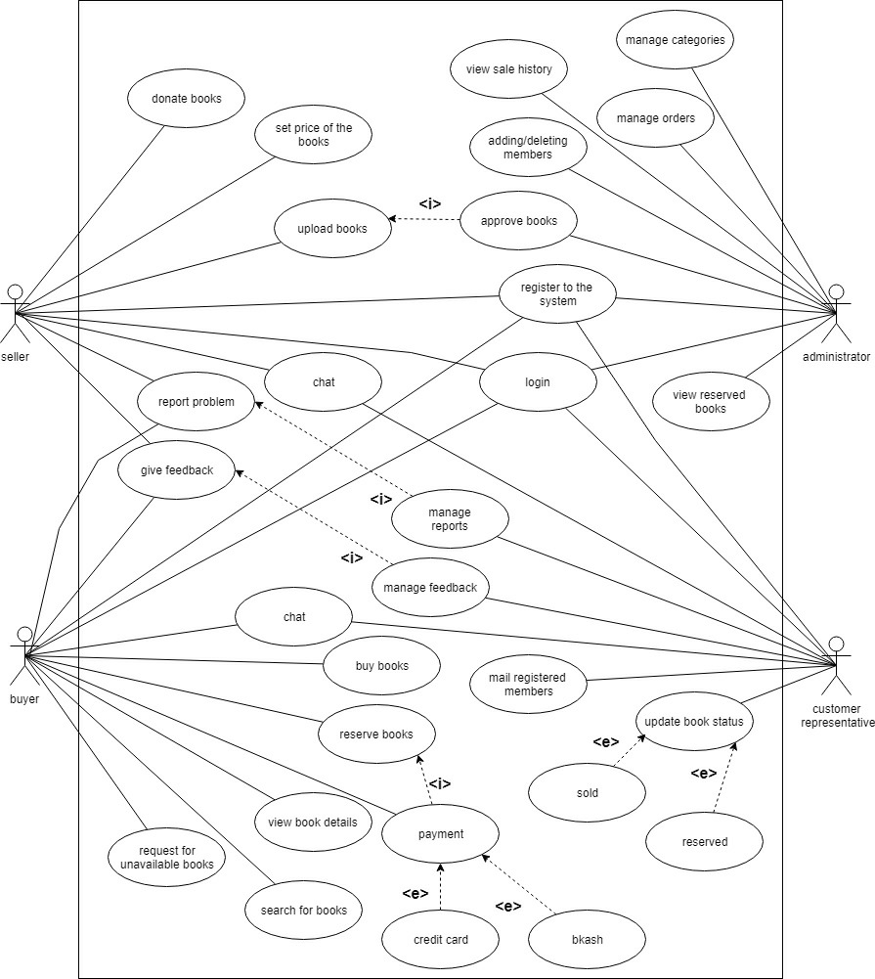

**4. External Interface Requirements**

**4.1 User Interface:**

* **Home Page**

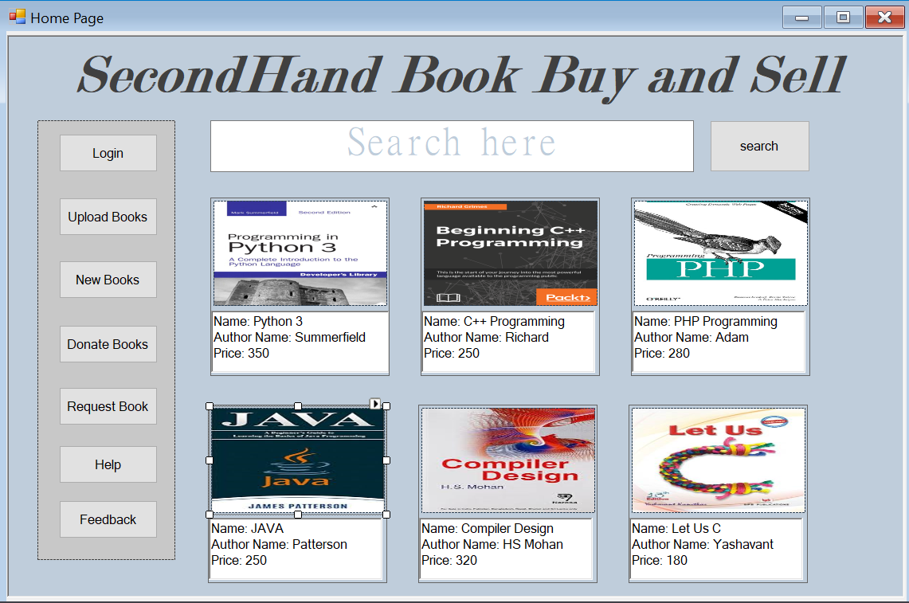

* **Login Page**

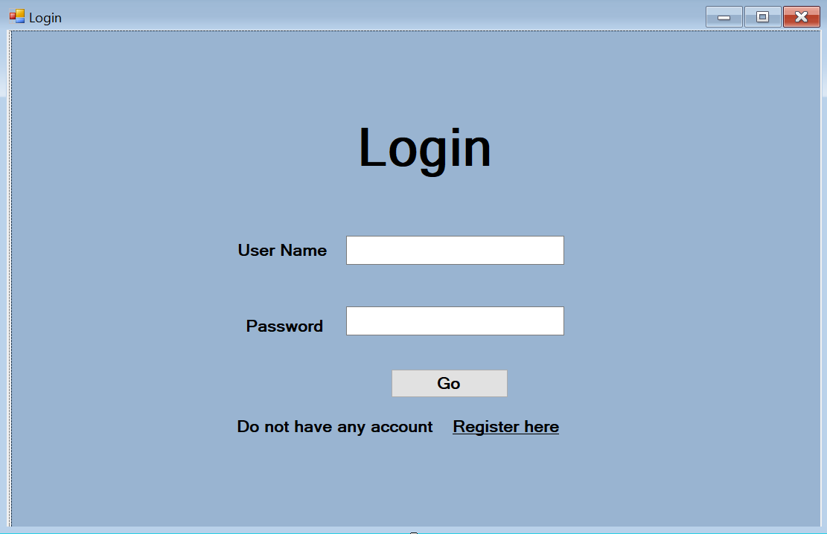

* **Registration Page**

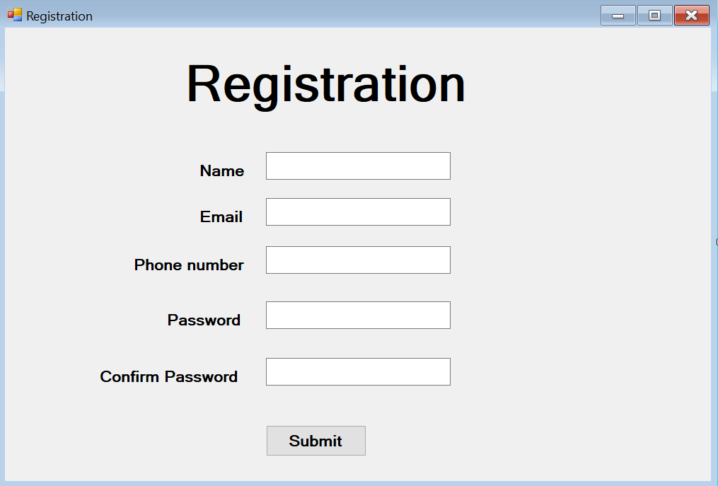

* **Admin Page**

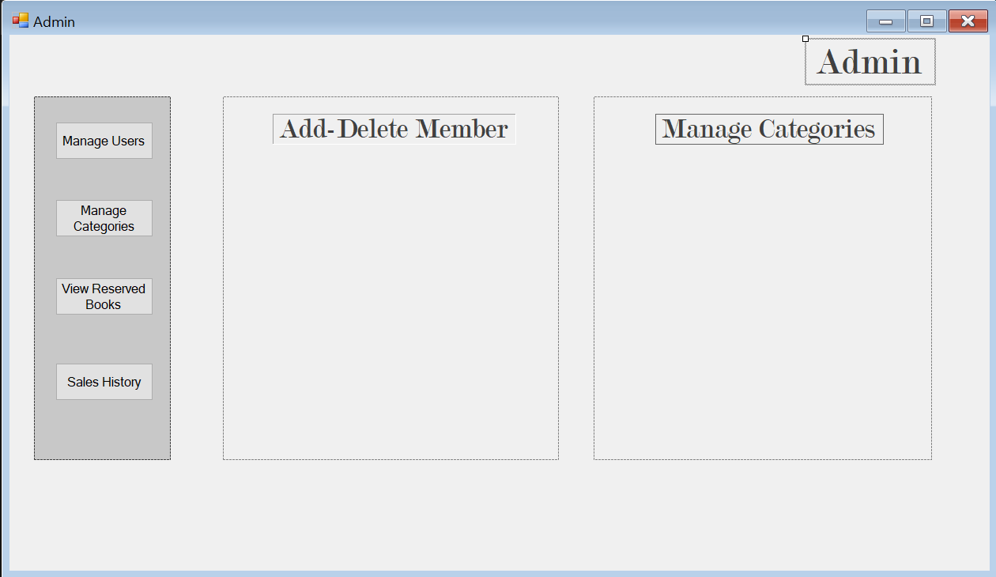

* **Customer Representative Page**

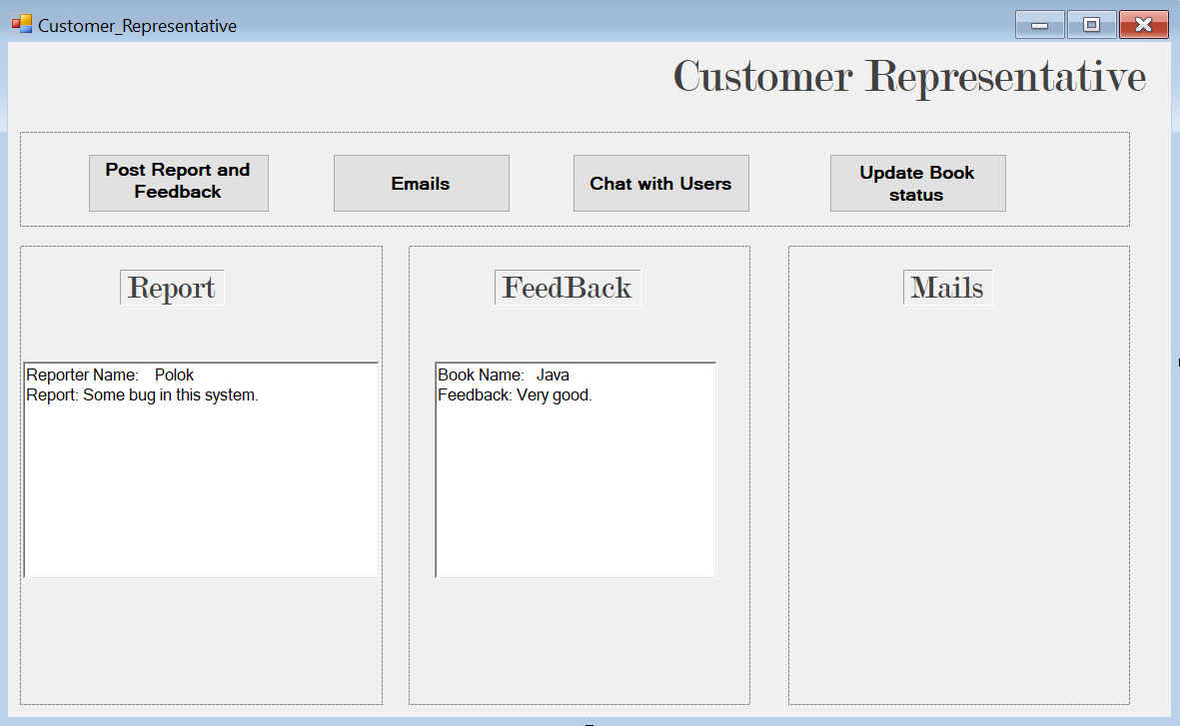

* **Member Page**

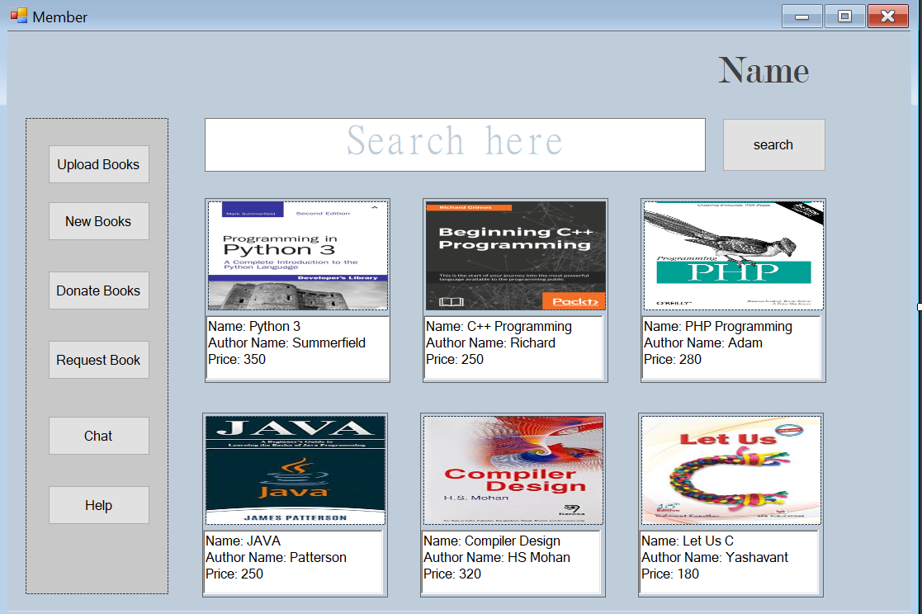

* **Upload Books Page**

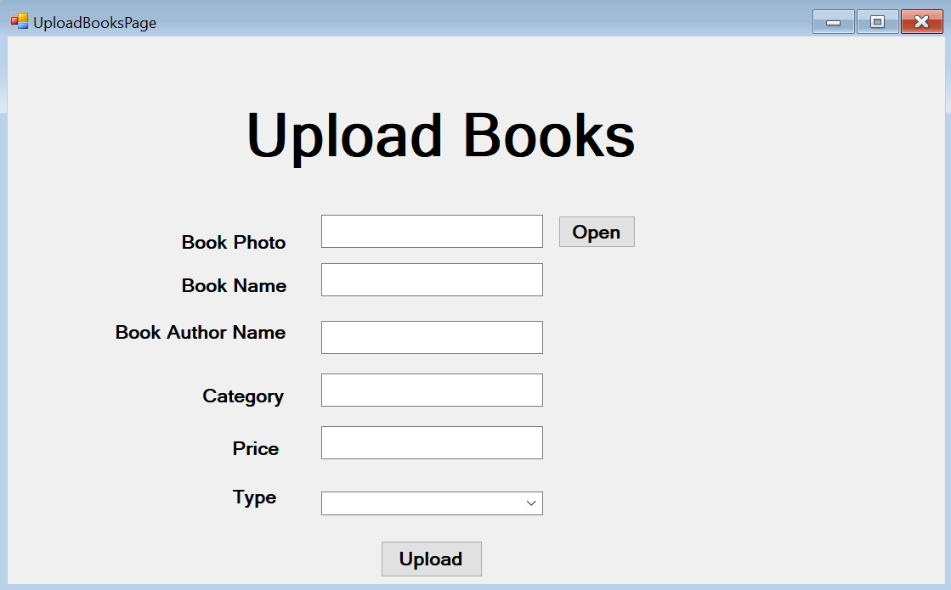

* **Buying Page**

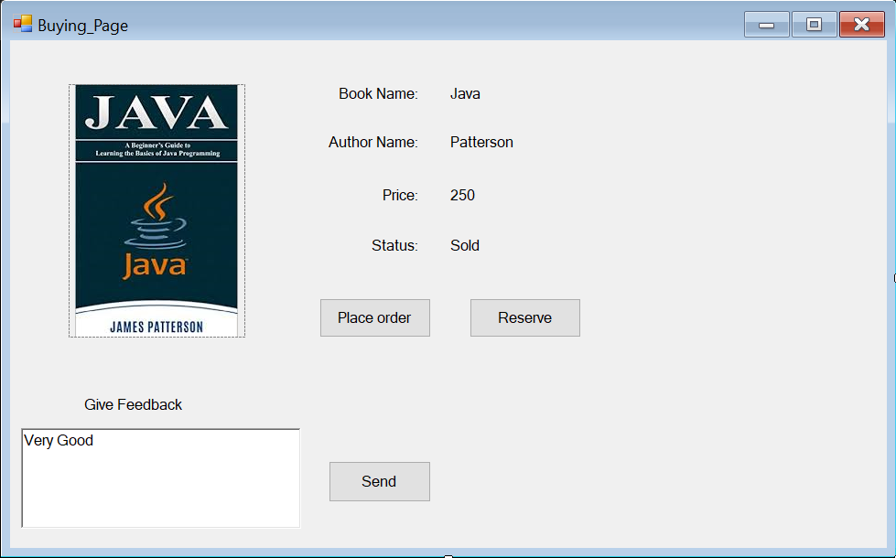

* **Reserved Books Page**

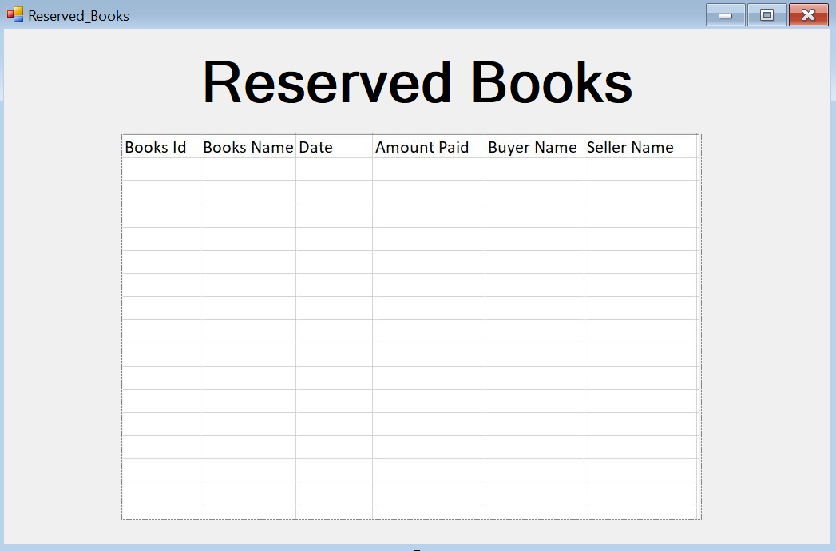

* **Sales History Page**

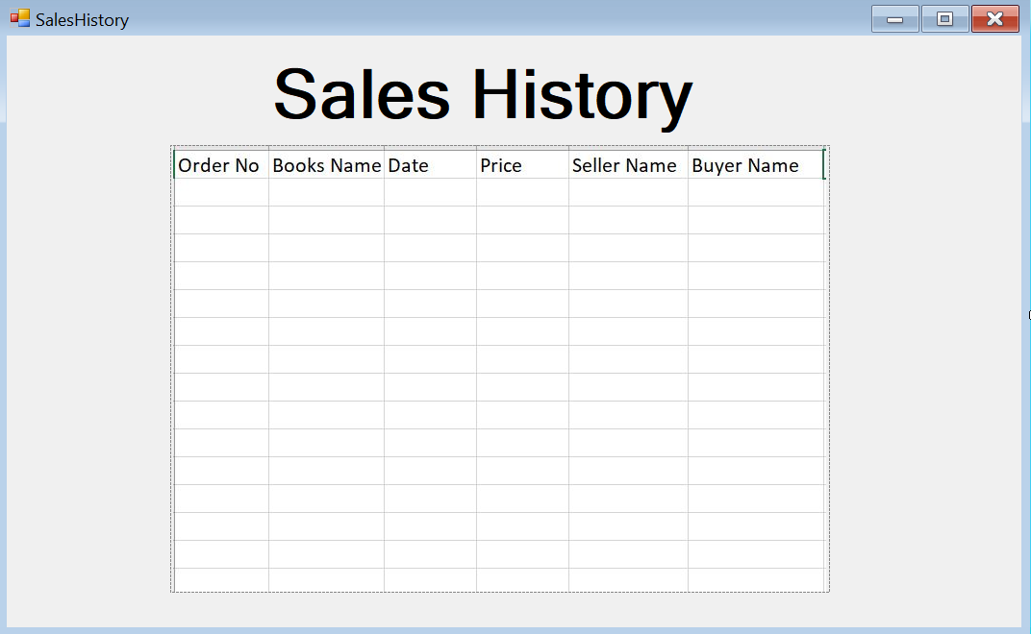

* **Help and Feedback Page**

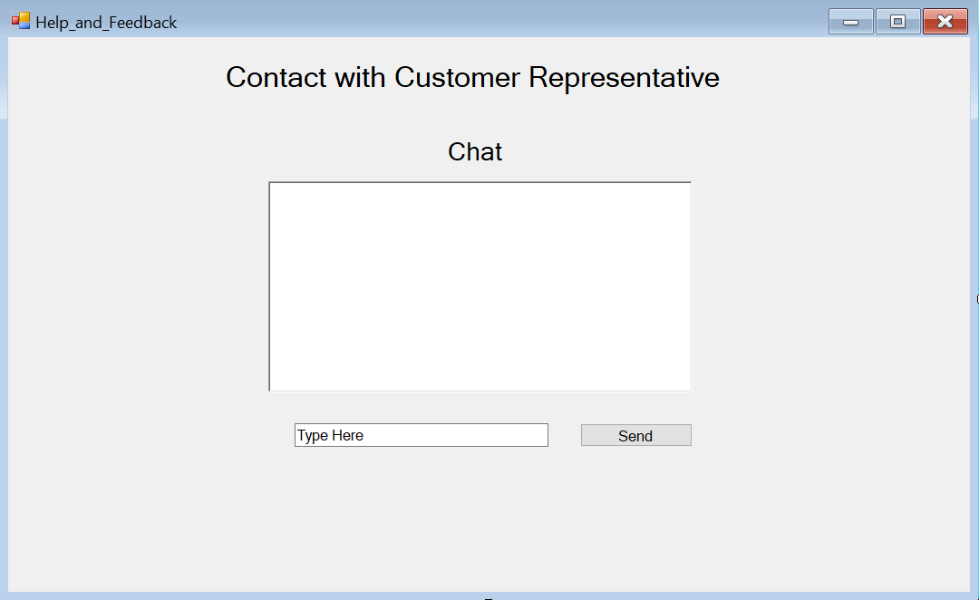

**4.2 Hardware Interface:**

Since the web portal does not have any designated hardware, it does not have any direct hardware interface. The hardware connection to the database server is managed by the underlying operating system on the web server.

**4.3 Software Interface:**

The web portal communicates with the database in order to get the information about the orders and members. The communication between the database and the web portal consists of operation concerning both reading and modifying data, only the admin is allowed to do that.

**4.4 Communication Interface:**

The communication between the different parts of the system is important since they depend on each other. However, in what way the communication is achieved is not important for the system and is therefore handled by the underlying operating system for the web portal.

**5. Quality Attributes**

**5.1 Usability:**

* Learnability: The portal interface is easy to learn. It will work as users expect with a little trial and error.
* User friendliness: The portal will be delightful to use and aesthetic. The interface conform to the user as opposed to forcing the user to conform to the technology.
* Informative: Steps and controls are clearly explained such that a user will not left wondering.
* Cause and effect: It is clear what a control does in the portal.
* Navigability: It is easy to locate what a user will be looking for with tools such as search book and navigation functions.
* Convention: Information, functions and navigation follows conventions such as avoiding blue, green and red texts.

**5.2 Performance:**

* Accessibility: The user will be able to quickly get to the functions needed to get his job done.
* Productivity: The user will be able to get more work done quickly.
* Flow: Navigating between interfaces is smooth. User will be able to flow through tasks without being interrupted.
* Error tolerance: Users are bound to make errors so, error tolerance is a necessity. The system is able to correct errors as opposed to giving up and displaying an error message.
* Error clarity: Once an error does occur, the system will notify the user about the error and its cause. Moreover, instructions on how to rectify the error will be defined.
* Compatibility: The interface is compatible with standard technologies.
* Efficient: The system allows work to flow efficiently.

**6. Data Requirements**

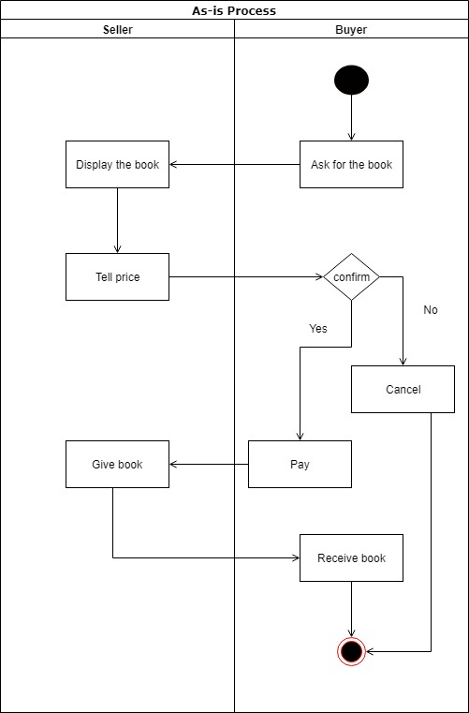**6.1.1 As- is Process diagram:**

**6.1.2 TO-BE Process diagram:**

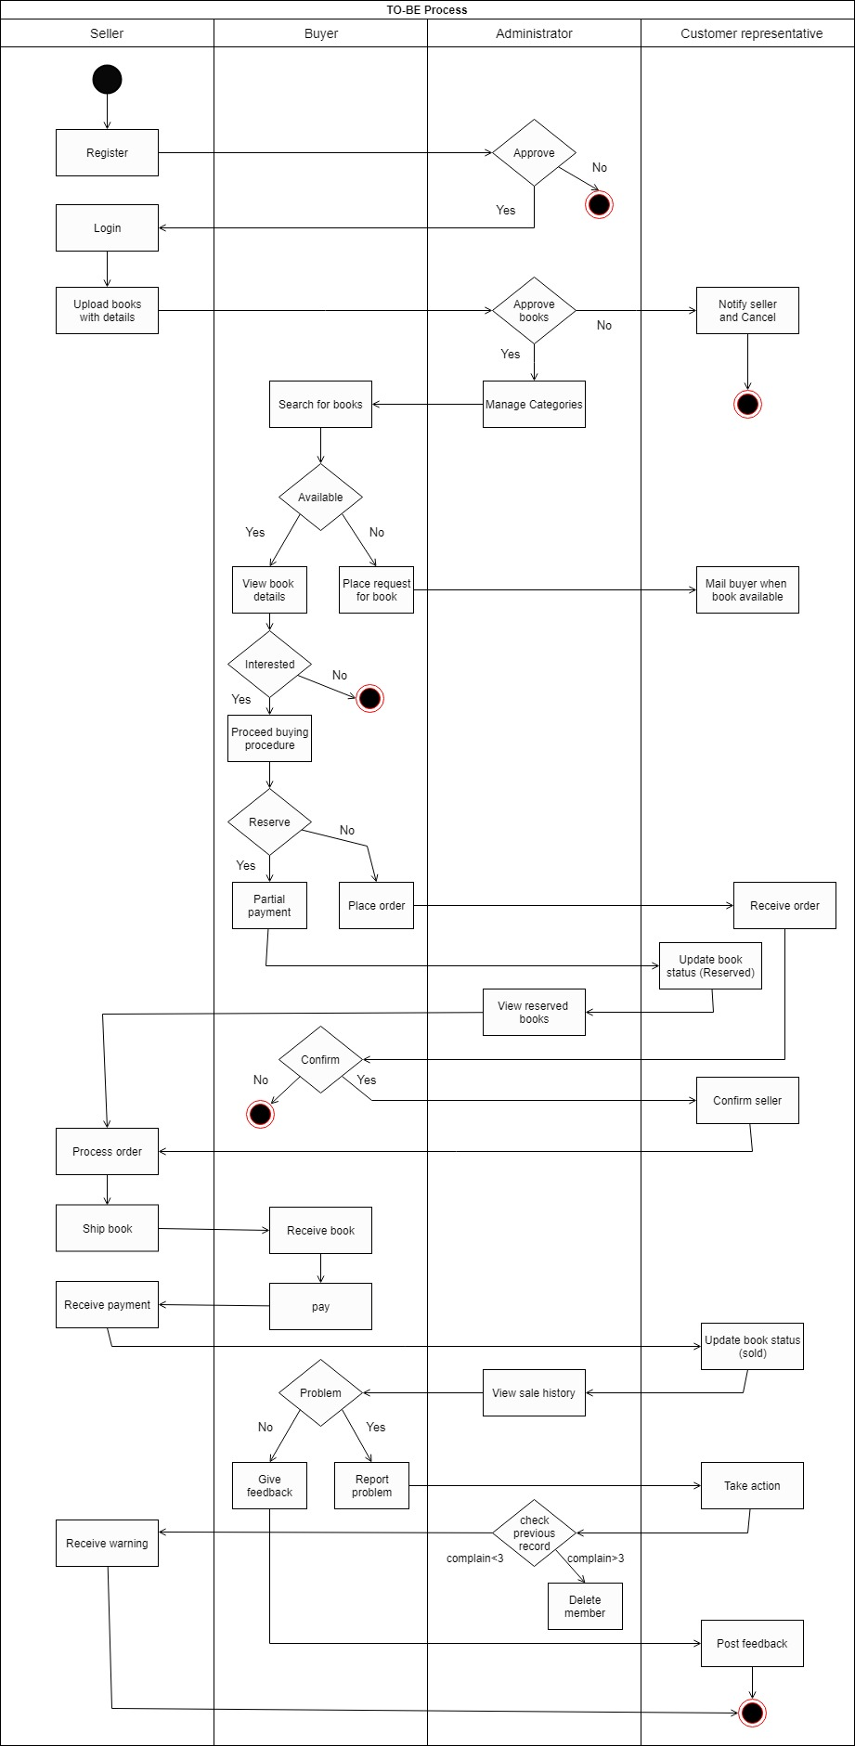

**6.2 Data Dictionary:**

|  |  |  |  |  |
| --- | --- | --- | --- | --- |
| Entity | Attribute | Type/Size | Validation | Key |
| Seller | SellerID | Number(06) | 000001-100000 | Primary |
| Seller | SellerName | Text | Required |  |
| Seller | SellerContactNo | Text | Required |  |
| Seller | SellerRegDate | Date | Valid Date |  |
| Buyer | BuyerID | Number(06) | 000001-100000 | Primary |
| Buyer | BuyerName | Text | Required |  |
| Buyer | BuyerContactNo | Text | Required |  |
| Administrator | AdminID | Number(02) | 01-10 | Primary |
| Administrator | AdminName | Text | Required |  |
| Administrator | AdminAddress | Text | Required |  |
| Administrator | AdminSalary | Number(06) | 40000-100000 |  |
| Administrator | AdminJoinDate | Date | Valid Date |  |
| CustRepresentative | CustRepresentativeID | Number(03) | 001-100 | Primary |
| CustRepresentative | CustRepresentativeName | Text | Required |  |
| CustRepresentative | CustRepresentativeAddress | Text | Required |  |
| CustRepresentative | CustRepresentativeSalary | Number(05) | 15000-50000 |  |
| CustRepresentative | CustRepresentativeJoinDate | Date | Valid Date |  |
| Book Info | BookName | Text | Required |  |
| Book Info | BookID | Number(05) | 10000-99999 | Primary |
| Book Info | BookDetails | Text | Required |  |
| Book Info | BookPrice | Number(4) | 0-9990 |  |
| Book Info | BookStatus | Text | Required |  |